Microsoft Azure - Starter Kits for Partners

Introduction to Starter Kits

Mobile and Media Services Scenario

Last Update: September 2015





**MICROSOFT MAKES NO WARRANTIES, EXPRESS, IMPLIED OR STATUTORY, AS TO THE INFORMATION IN THIS DOCUMENT.**

The information contained in this document represents the current view of Microsoft Corporation on the issues discussed as of the date of publication. Because Microsoft must respond to changing market conditions, it should not be interpreted to be a commitment on the part of Microsoft, and Microsoft cannot guarantee the accuracy of any information presented after the date of publication.

Complying with all applicable copyright laws is the responsibility of the user. Without limiting the rights under copyright, no part of this document may be reproduced, stored in or introduced into a retrieval system, or transmitted in any form or by any means (electronic, mechanical, photocopying, recording, or otherwise), or for any purpose, without the express written permission of Microsoft Corporation.

Microsoft may have patents, patent applications, trademarks, copyrights, or other intellectual property rights covering subject matter in this document. Except as expressly provided in any written license agreement from Microsoft, the furnishing of this document does not give you any license to these patents, trademarks, copyrights, or other intellectual property.

The descriptions of other companies’ products in this document, if any, are provided only as a convenience to you. Any such references should not be considered an endorsement or support by Microsoft. Microsoft cannot guarantee their accuracy, and the products may change over time. Also, the descriptions are intended as brief highlights to aid understanding, rather than as thorough coverage. For authoritative descriptions of these products, please consult their respective manufacturers.

© 2014 Microsoft Corporation. All rights reserved. Any use or distribution of these materials without express authorization of Microsoft Corp. is strictly prohibited.

Microsoft and Windows are either registered trademarks of Microsoft Corporation in the United States and/or other countries.

The names of actual companies and products mentioned herein may be the trademarks of their respective owners.

Contents

Overview 4

The Mobile Opportunity 4

The Proposed Solution for Mobile 5

Key Sales Scenarios for Media Services 6

The Proposed Solution for Media Scenarios 7

Partner Needs 8

Introduction to Starter Kits 8

Starter Kits - Partner Benefits 8

# Overview

In this document, we will cover the challenges our customers are facing with Mobile and Media Services scenarios, and how Microsoft Azure can solve this problem.

We also cover what application patterns will mostly benefit for moving to the Cloud.

Finally, we introduce the concept of a “Starter Kit”, essentially demonstrate how to leverage this concept of a packaged offering to accelerate the Partner sales and deployment cycle.

# The Mobile Opportunity

By 2020 we will live in a world of 50 billion connected devices that need different type of Applications and all generating large amounts of data just waiting to be analyzed.

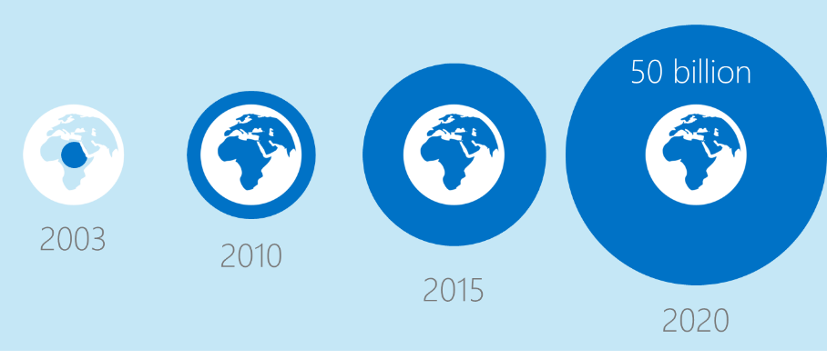

Gartner estimated that by the end of 2013, consumer cloud services for accessing content would be integrated into 90% of all connected devices

* Nearly 2/3 of consumers use their **smartphones/tablets** to get information about products, brands, or destinations at least 3-4 days/week.
* 29% of today’s global workforce are **anytime, anywhere information workers** who use **3+ devices**, work from multiple locations and use many apps.
* By 2016, **tablets and smartphones** will put power in the pockets of 1.4 billion global consumers.

We are experiencing rapid evolution with big opportunities for partners in the world of applications. The application market is growing at an unprecedented rate.

* The digital universe will grow to 44 trillion GB by 2020
* By 2020, we will live in a world of 50 billion connected devices all generating large amounts of data just waiting to be analyzed
* By 2017, worldwide cloud services spending with grow to an enormous $107.2 billion dollars
* And today, 69% percent of employees access business applications on their own personal devices

**What does this mean for partners?**

* The cloud market is growing at an explosive rate, representing huge opportunities for partners. $1 for every $5 spent on application will be consumed via the cloud. Partners can monetize on this huge market opportunity by helping customer modernize their applications and move them to the cloud.

# The Proposed Solution for Mobile

Azure Mobile Services makes it fast and easy to build mobile apps that scale. With Mobile Services, you store data in the cloud, authenticate users, send push notifications, and add custom server-side code. Mobile Services fully supports native Windows Store, Windows Phone, Android, iOS, and HTML5 development. The core Mobile Services functionality is also exposed through a powerful and flexible REST API so that you can build connected cross-platform apps and reach every user on every device.

Use apps, not just ads, to build your brand and engage your customers

Extend your core service from the browser to devices

Build employee facing apps that drive mobile productivity in the workforce

**Store Your Data**

Simple storage provisioning is one of the core tenets of Mobile Services. Each Mobile Services subscription has ready access to a free 20 MB SQL database, which makes it easy to store relational data.

Set individual permissions on insert, read, update, and delete operations for each table.

Server-side code gives you the option of connecting to additional data stores—in Windows Azure, from 3rd parties, and on-premises.

**Authenticate Your Users**

Mobile Services eliminates the need to write, configure, and test custom authentication systems. Register your application with Facebook, Twitter, Microsoft, or Google and then safely store your credentials in your Mobile Service. After your users log in, Mobile

Services will verify their credentials on the server.

Want to keep things “in-house”? Use server-side extensibility to integrate with Windows Azure Active Directory or your own custom identity system.

No matter which authentication route you choose, you can restrict and manage access to all your Mobile Services resources.

**Push Notifications to Every Device, Every User**

Mobile Services integrates with each platform’s push notification systems—MPNS for Windows Phone, WNS for Windows Store, GCM for Android, and APNS for iOS. To send push notifications, just upload your credentials, code push.apns.send, and then specify the device token and payload.

Mobile Services integrates with Notification Hubs to provide the ability to broadcast push notifications to millions of devices.

**Connected Services**

Server-side code allows you to enhance your data operations with custom logic. You can also send push notifications, SMS, and email or connect to other Windows Azure services and utilize add-ons from the Windows Azure Store.

Any 3rd party service with an exposed API can also easily integrate with your Mobile Services powered application. That means services from companies like New Relic, Pusher, SendGrid, and Twilio work seamlessly with your app.

You can connect your mobile app to on-premises systems by using Service Bus Relay with Mobile Services.

**Run Code on Demand**

Mobile Services allows you to run your server-side code when you want to—whether that’s once or on a fixed schedule. This allows you to periodically purge old or duplicate data from tables, process and resize user submitted images, as well as query aggregate data from an external web service.

Not only can you run your code when you want to, you can expose that code to external services making REST calls.

# Key Sales Scenarios for Media Services

**Streaming**

Live or Video on Demand streaming using cloud technologies for expanded reach, lower costs, and greater flexibility. Manage the encoding, storage, and streaming media libraries to all of the leading consumer devices.

**Web video on Microsoft Azure for Agencies**

Comprehensive set of services and tools for video preparation, management, and publishing for digital marketing platforms, user-generated video, and breadth media streaming scenarios.

**In-house production**

Transition internal digital media workflows from on-premises to the cloud to take advantage of increases in speed and scale for fast results.

**Enterprise video management**

High-quality internal video management system for the enterprise. Distribute and manage corporate communications, IT, Human Resources (HR) content, and training courses. Includes, but not limited to, Microsoft Office 365 Video.

# The Proposed Solution for Media Scenarios

Azure Media Services is being used to power consumer and enterprise streaming solutions worldwide. Combining powerful and highly scalable cloud-based encoding, encryption, and streaming components, Azure Media Services is helping customers with valuable and premium video content to easily reach larger audiences on today’s most popular digital devices such as tablets and mobile phones. Live Broadcast Events – from sports, news, concerts to CEO Town Hall meetings - and linear channels including popular over-the-top programming networks and services are turning to Azure Media Services as their platform of choice. Additionally, with exciting new features such as Media Indexing to enhance discoverability, Cross-Platform Players to simply distribution, and Cloud DVR capabilities to move easily from Live content to on-demand programming and a large ecosystem of value-add third party partners, Azure Media Services is truly providing customers with video content a best-of-breed solution.

**Create Premium On-Demand solutions**

Quickly deliver scalable subscription VOD, transactional VOD, advertising VOD, and over-the-top services. Leverage our CDSA and ISO certified cloud to reduce costs and deliver to multiple platforms from Azure datacenters worldwide.  
Use industry-standard PlayReady DRM or AES encryption to protect your content.  
Seamlessly integrate with the Azure Media Services streaming platform to optimize cost by encoding once and delivering in multiple formats with Dynamic Packaging.  
Azure Media Encoder and Media Encoder Premium offer studio grade encoding at cloud scale.

**Create Live Broadcasting solutions**

Azure Media Services provides a highly flexible platform capable of handling everything from small scale local events to the largest events on the planet like the FIFA World Cup and 2014 Sochi Winter Olympics.

Use cases include event based streaming and 24x7 linear streaming with cloud DVR workflows.

**Scale your media distribution with CDN**

Azure CDN allows you to deliver high-bandwidth content to end-users around the world with low latency and high availability via a robust network of global data centers. It is designed to send audio, video, applications, images, and other files faster and more reliably to customers using servers that are closest to each user. This dramatically increases speed and availability, resulting in significant user experience improvements.

# Partner Needs

Partners want to make profitable businesses by deploying and selling Microsoft Azure.

They also want to sell and deploy Mobile and Media Services Scenarios, but do not have the experience or understanding to say what is possible or know possible ways to sell the value of it or set it up.

At the same time, Partners and Customers have expressed a need to have more capacity that is flexible in their businesses for running VMs for various purposes. They want to spend less time managing hardware and IT and more time selling and deploying.

# Introduction to Starter Kits

This concept is a set of deliverables, packaged as an offering that are named as a starter kit. Starter kits are designed to show a partner a specific scenario in Azure that could be possible for them to build and equip them in the technical sales cycle. Each kit will include:

1. A Description of the partner benefit for using and participating in the kit.
2. An assessment questionnaire and guidance that Partners could use with a customer.
3. An Architecture Topology presentation for a recommended way to implement the specified scenario.
4. A cost estimator (based on retail pricing) for implementing the recommended scenario on Azure.
5. A Statement of Work template for implementing the recommended scenario that a partner could use.
6. Hands on Labs a Partner can self-study to build technical skill implementing the recommended scenario.

# Starter Kits - Partner Benefits

1. Reduce time in creating a proposal for a customer through a sale and deployment template
2. Reduce the learning curve cost by focusing on a proven scenario
3. Help assess and determine the technical requirements for migrating existing Applications to the Cloud
4. Sell, estimate cost and deploy working solutions to your customer.
5. Get tools and templates to use when discussing a Mobile and Media Services deployment with your customers.
6. Receive a recommended set of topology diagrams for implementing a Mobile and Media Services scenario on Azure.
7. Receive guidance for self-study for learning the recommended Mobile and Media Services scenario at a technology level.